Becoming a Reflective Information Scientist

Group - 2

## Task 1. Colour Spaces:

### What is the difference between additive and subtractive colour models?

Ans: Additive colour models reproduce a broad range of colours when those lights are added together towards the key colour white. RGB is an additive colour model. Whereas subtractive colour models use dyes, inks, pigments, or filters to absorb some wavelength of light towards the key colour black. CMYK is a subtractive colour model.

### What are the typical uses for these different colour models? When is RGB preferred? When is HSV preferred? When is CMYK preferred?

Ans: The RGB model is used by devices like television, computers, and also in photography and coloured lighting. This model is preferred when we want to design for digital screens, like television and computers. The CMYK colour model is used in printing work. This model is preferred when we want to print materials accurately representing how colours will appear when printed using inks. The HSV colour model is used for colour pickers and image editing softwares. This model is preferred for colour manipulation tasks where adjusting hue, saturation, and value independently based on human requirement.

## Task 2. Colour Gamuts:

### What is the difference between SDR (Standard dynamic range) and HDR (High dynamic range) video?

Ans: SDR uses 8-bit color depth which limits it to 16.7 million colors and brightness range of 0-100 nits while HDR uses 10-bit or 12-bit color depth which allows it to manage over 1-billion colors and brightness level up to 10000 nits. The SDR video is commonly used in televisions, computer monitors, and mobile devices. In these devices the HDR visual benefits are less observed.

The HDR video format can be used in movies, TV shows, and photography.

### Using the site www.wide-gamut.com, verify whether your phone and computer support a wide colour gamut. Each group member should document the result of this test in the submission.

Ans: The test result has been recorded in the form of recording, please go through the [attached link](https://drive.google.com/file/d/1pqCbXVYYvX58fRxCbaLmFaKCVCdYUnz8/view?usp=sharing).

## Task 3. Estimate Video Size:

### Your calculations for the file size and the answer to the question about downloading.

Ans:

Resolution each frame has = 3840 * 2160 pixels with 3 color channels (RGB)

Each channel is encoded with 8 bits = 1 byte

data/pixel = 3 * 8 bits = 3 bytes

data/frame = 3840 * 2160 * 3 bytes = 24883200 bytes = 23.73 MB

data/second = 23.73 * 60 [ Since the video is 60 frames/second]

= 1423.8 MB = 1.39 GB

Total data for 30 minutes = 1.39 GB * 60 * 30 = 2502 GB

## Task 4. Six Differences:

### In the submission document, include a list of differences between the two images (in words) and an image that clearly shows how to identify these differences. You should also mention what operations you used to make this image

Ans: The difference between the two images are listed below:

Image1:

* The citations of the image on the left shown vertically
* “HENRY BOLTINEFF” shown at the left bottom corner on the tree trunk
* The cat tail difference shown
* “5:17” on the branch
* The bushes difference near the tree
* The wrist movement of the lady
* Mouth difference of the lady
* Hair is shorter
* The man sweater has only two black stripes on the yellow jacket

Image2:

* Missing citations
* No words at the bottom left corner
* The cat tail difference
* Nothing shown on branch
* The bushes difference near the tree
* Wrist movement of the lady
* The mouth is little open compared to the first
* Hair is longer than the first
* The man sweater has 3 stripes in total on the yellow jacket

Here is the image that clearly shows differences between the two:  
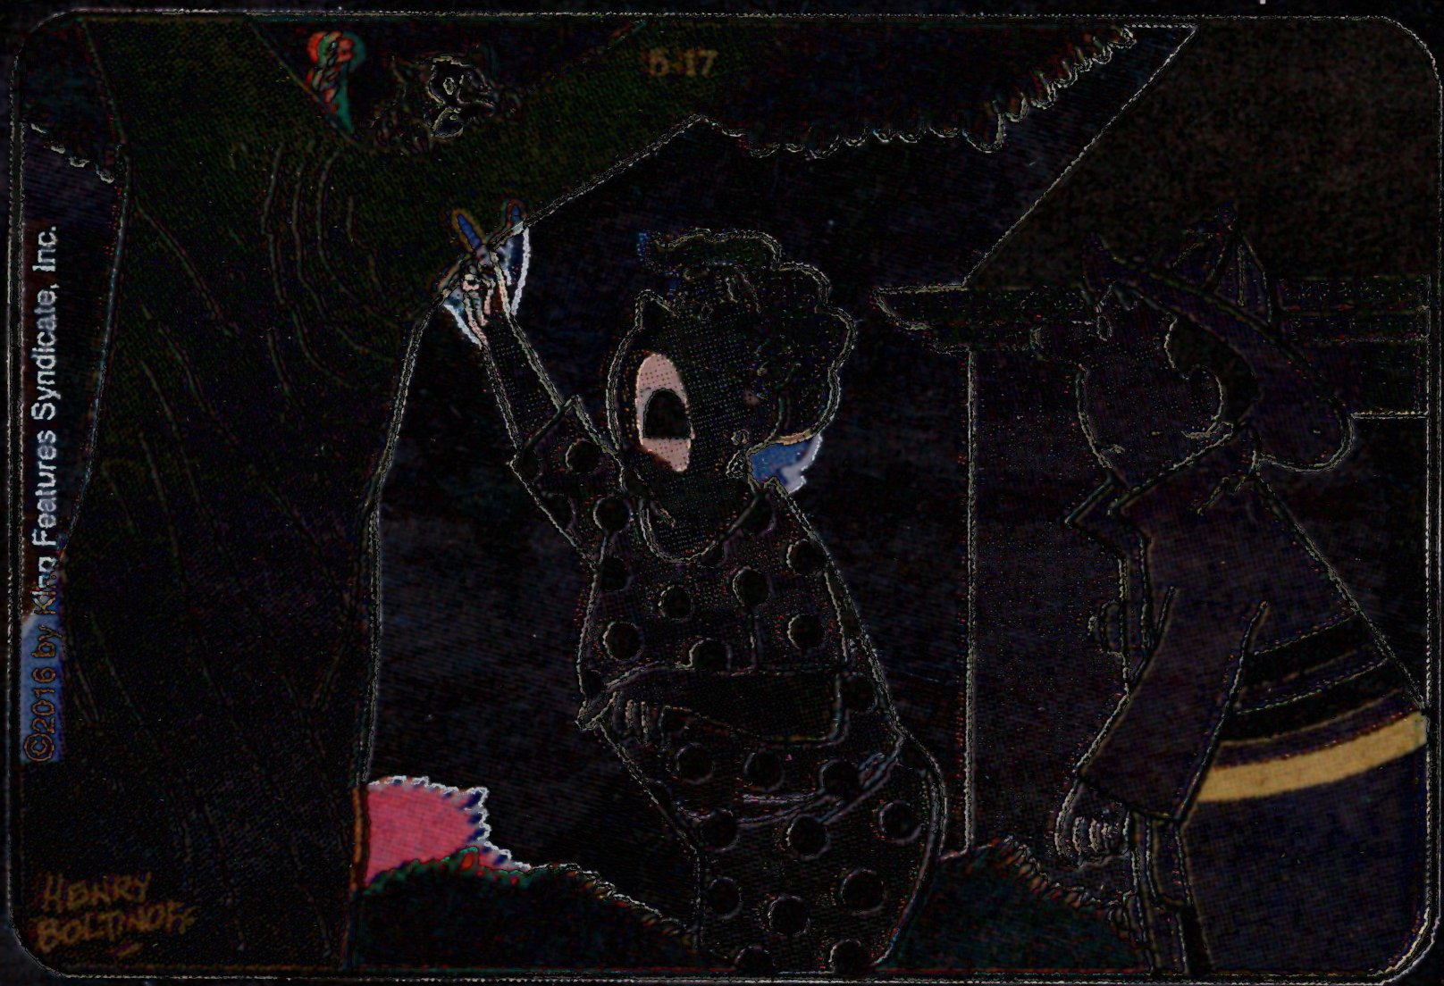

## 

## Task 5. QR Code:

### In your submission, write about your observations. Did any transformation affect the functionality of the QR code? What does this tell you about QR code technology?

Ans:

On zooming in or zooming out the QR doesn’t work.

On changing the aspect ratio the QR works.

On rotating the image by different angles the QR still works.

On adding noise to the image the QR still works.

On changing pixel colours, the QR doesn’t work.

## Task 6. Image Registration:

### Your submission document should have the merged image produced in the final step. Also, include some comments about what registration did to this set of images.

Ans: The image registration helped in creating the stack (as a pipeline) of the images imported in the form of sequence. In our case it was 4, so it created a stack with four images. Then that stack helped in picking up all the images together in the montage process and created a single image with it. The coloured form of that image is shown below:

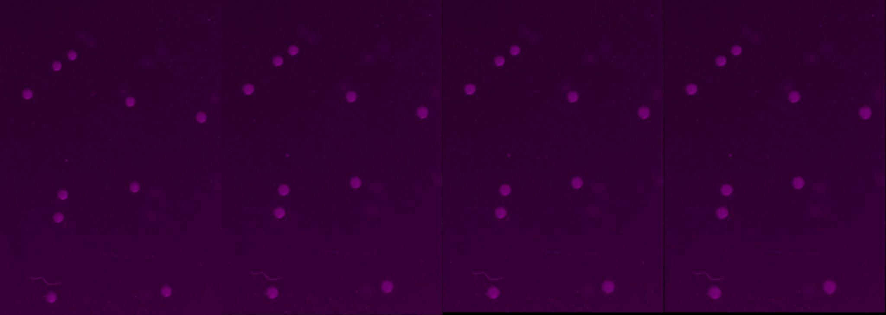

## Task 7. Steganography:

### Your submission document should have the images showing hidden information from parts a and b. Also, include some comments on how information was hidden in the two parts.

Ans: The images showing hidden information as below:

Part a: Guessing the word text colour wasn’t up to level to be visible, so when we enhanced the contrast then got visible.



Part b: Shown hidden information by taking both the image files, some data of images are only shown on some specific background.

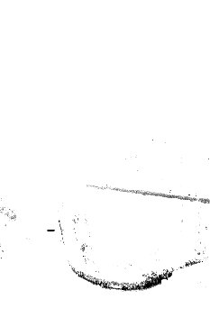

## Task 8. Invertibility and Idempotence:

### For each part, indicate whether the transformation is invertible/idempotent or not. Justify your answer.

Ans:

a. f(x) = x + 1:

* It is an **invertible** transformation as f(2) not equal to f(3)
* It is **not idempotent** as f(f(2)) not equal to f(2) as f(2) = 3 and f(f(2)) = f(3) = 4

b. f(x) = x and (75)10:

* It is an **invertible** transformation as f(x) is not equal to f(y)
* It is **idempotent** as f(f(2)) is equal to f(f(2)) as f(2) = 2 and f(f(2)) = f(2) = 2

c. f(x) = x or (75)10:

* It is an **invertible** transformation as f(x) is not equal to f(y)
* It is **idempotent** as f(f(2)) is equal to f(f(2)) as f(2) = 2 and f(f(2)) = f(2) = 2

d. f(x) = x xor (75)10:

* It is an **invertible** transformation as f(x) is not equal to f(y)
* It is **not idempotent** as f(f(2)) is not equal to f(f(2)) as f(2) = 153 and f(f(2)) = f(153)

e. f(x) = not x:

* It is an **invertible** transformation as f(x) is not equal to f(y)
* It is **idempotent** as f(f(2)) is equal to f(f(2)) as f(2) = 1 and f(f(1)) = f(2) = 1

## Task 9. Composition:

### For each part, the graphs for g(f(x)) and f(g(x)). You can draw the graphs by hand, digitize them and include the images in your submission document.

### Ans: The following are the graphs for the g(f(x)) and f(g(x) of

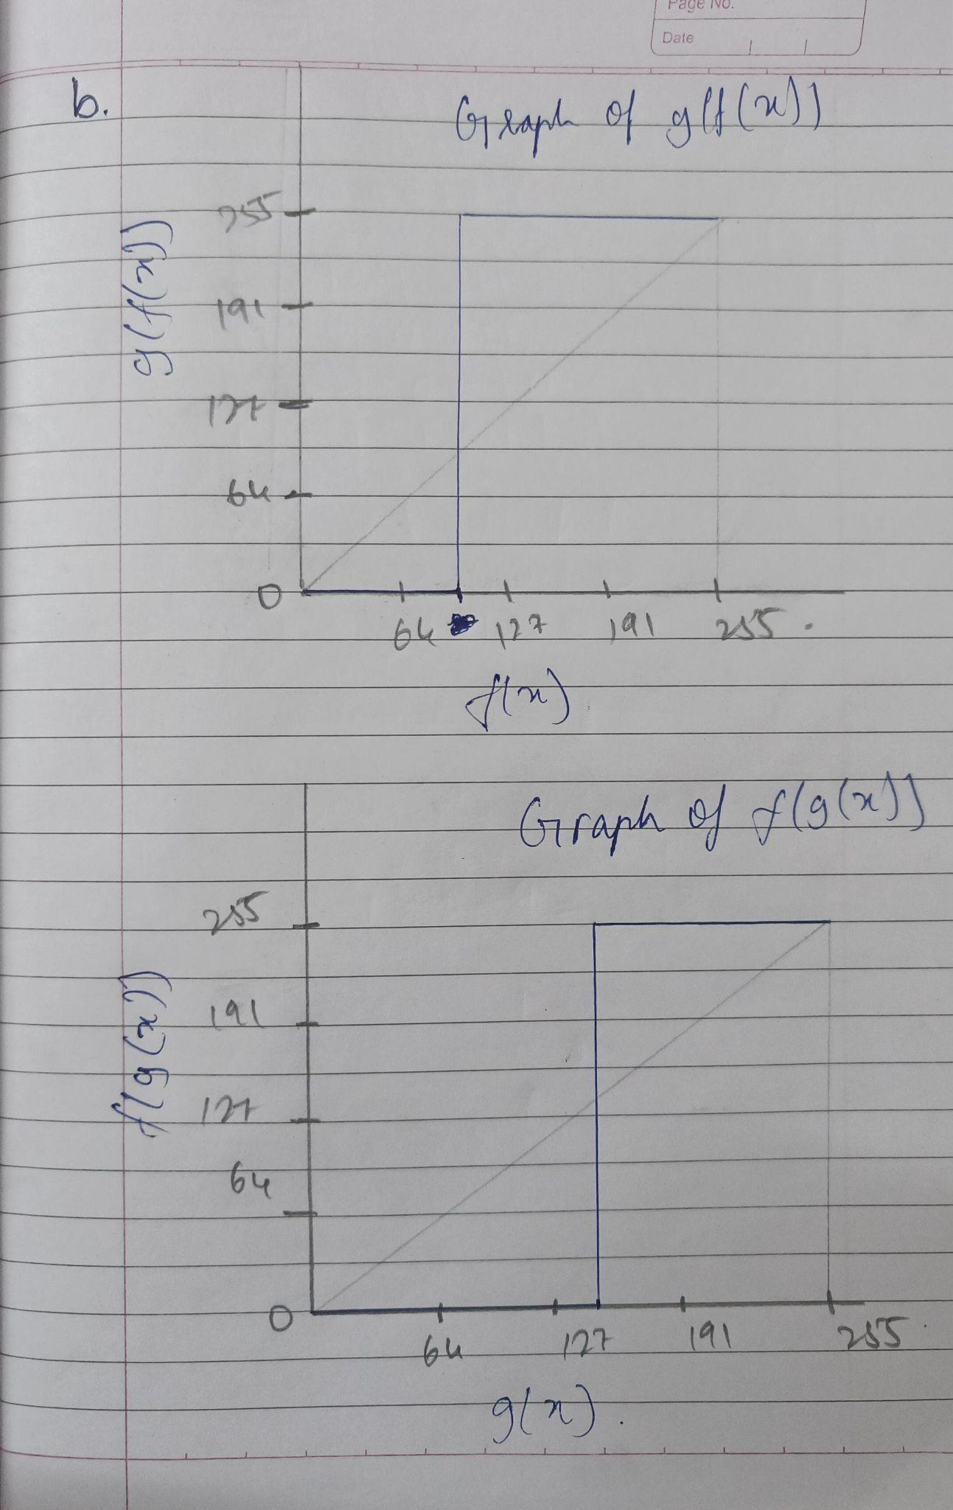

## Task 10. Commutativity of transformations:

### For each part, indicate whether the two transformations commute or not. Justify your answer.

Ans:

a. f(x) = x + 1, g(x) = x − 1

* f(2) = 2 + 1 = 3, g(2) = 2 - 1 = 1
* f(g(2)) = f(1) = 1 + 1 = 2
* g(f(2)) = g(3) = 3 - 1 = 2
* Therefore it is **commutative** in this case

b. f(x) = x and (128)10, g(x) = x or (67)10

* f(2) = 2

******************************************************